RAD Master Document

Team G

Troy Lucero

Aveneil Singh

Sean Boaden

Gholamreza Aminy

Contents

Analysis and Setup 2

SOURCE CONTROL 2

Task Matrix 2

Sprint One 3

SOURCE CONTROL 3

PROJECT MANAGEMENT PLAN 4

TEST PLAN 5

Introduction 7

Test Methodology 8

Resource & Environment Needs 10

Terms/Acronyms 10

ANALYSIS REPORT 11

CITE business rules for software development 11

CITE Managed Services Quality Assurance 12

Acme Entertainment Pty Ltd development requirements 12

MULTI-PLATFORM REPORT 14

Multi-Platform Tests 15

Sprint Two 19

# Analysis and Setup

SOURCE CONTROL

[GitHub](https://github.com/sean-b765/RAD-Project) repository

## Task Matrix

|  |  |  |  |  |  |  |
| --- | --- | --- | --- | --- | --- | --- |
| **Sprint One** | **GANTT Chart** | **Test Plan** | **Analysis Report** | **Multi-Platform Report** | **Source Control** | **Demonstration** |
| *Sean* |  |  |  | 29/05 | 2/06 |  |
| Aveneil | Completed 4/06 |  |  |  |  |  |
| Gholamreza |  | 29/05 |  |  |  |  |
| Troy |  |  | 1/06 |  |  |  |
|  |  |  |  |  |  |  |
| **Sprint Two** | **GANTT Chart** |  | **Analysis Report** |  |  |  |
| Sean |  |  |  |  |  |  |
| Gholamreza |  |  |  |  |  |  |
| Troy |  |  |  |  |  |  |
|  |  |  |  |  |  |  |
|  |  |  |  |  |  |  |
|  |  |  |  |  |  |  |
|  |  |  |  |  |  |  |
|  |  |  |  |  |  |  |
|  |  |  |  |  |  |  |
|  |  |  |  |  |  |  |
|  |  |  |  |  |  |  |
|  |  |  |  |  |  |  |

# Sprint One

Scrum Master: Sean B

## SOURCE CONTROL

Project from Web Programming will be uploaded to GitHub. At the end of Sprint one, changes will have been pushed to master branch.

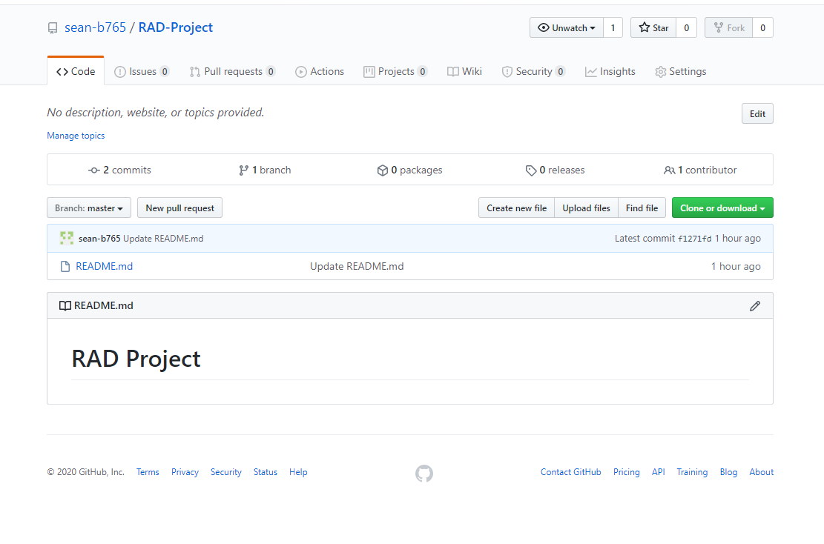

Pull Requests

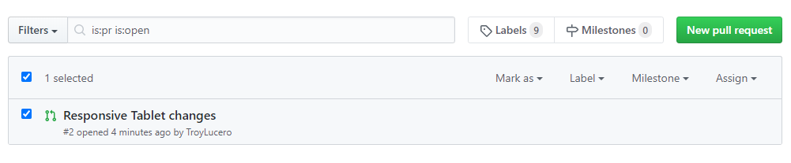

## PROJECT MANAGEMENT PLAN

By: Aveneil

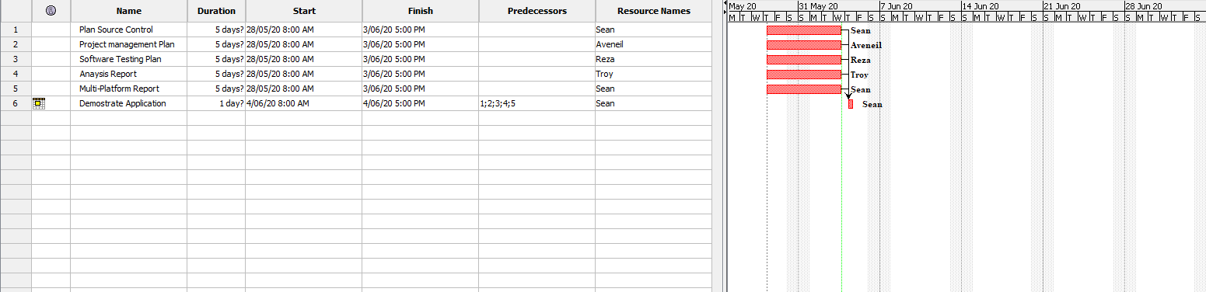

## TEST PLAN

By: Gholamreza

**Project: Movie Database**

**Client: Acme Entertainment Pty Ltd**

|  |  |  |  |
| --- | --- | --- | --- |
| **Version** | **Change Date** | **By** | **Description** |
| V0 | 28/5/2020 | Group G | First Version |
|  |  |  |  |
|  |  |  |  |

Test plan 1

1. Introduction 3

Scope 3

In Scope 3

Out of Scope 3

Quality Objective 3

Roles and Responsibilities 3

2. Test Methodology 4

Overview 4

Test Levels 4

Bug Triage 4

Suspension Criteria and Resumption Requirements 5

Test Completeness 5

3. Test Deliverables 5

4. Resource & Environment Needs 6

Testing Tools 6

Test Environment 6

5. Terms/Acronyms 6

### Introduction

#### Scope

##### In Scope

The whole package including GUI, functional and non-functional requirements of the software are in the scope of this document and will be tested in different stages and sprints.

##### Out of Scope

None

#### Quality Objective

The ultimate objective of this plan is to ensure the application under test meets the functional and non-functional requirements as agreed on the contract. The AUT will also be a quality and user friendly product with no bugs.

#### Roles and Responsibilities

To ensure a clear understanding of the roles and responsibilities to achieve the above-mentioned quality objective the following roles and responsibilities are defined for this plan:

* Test Manager: has the overall responsibility of executing this plan. Test manager will schedule and implement the tests and set action plans to rectify the triaged bugs in cooperation with other team members
* QA Analyst: QA Analyst has the responsibility to monitor the proper implementation of this plan, perform regular audits and report to the Test Manager for corrections and Project Manager for further decisions.
* Configuration Manager
* Developers: are responsible to understand and analyze the assigned tasks and do the task on the assigned time ready for test. They will fix defined bugs during the tests reported by the Test Manager.
* Installation Team: They are responsible to ensure the software can be installed with minimum efforts and report any bugs to the Test Manager

### Test Methodology

#### Overview

Choosing the RAD software development requires a suitable test method like Agile in which all the functional and non-functional tests can be completed in each sprint. So the Agile method will be used for this testing plan as in Agile:

* software is developed in incremental, rapid cycles
* Interactions amongst customers, developers and client are emphasized
* focuses on responding to change rather than extensive planning
* every release of the project is tested thoroughly
* any bugs in the system are fixed before the next release

#### Test Levels

Test Levels define the Types of Testing to be executed on the Application Under Test (AUT).

The AUT will be tested in the below levels

* System Testing.
* Acceptance Testing.

The following tests will be performed to ensure clients requirements:

* Functional and Regression Testing;
* GUI and Usability Testing;
* Accessibility Testing;
* Performance Testing;
* System / Integration Testing;
* User Acceptance Testing (UAT).

#### Bug Triage

To ensure fixing the bugs in a timely manner it is absolutely important to prioritize them so that the urgent ones, which are mainly functional reuquirements, get priority in scheduling the tasks to fix the bugs.

The triage would be based on the following requirements:

* GUI and Usability
* Functional
* Accessibility
* Performance

#### Suspension Criteria and Resumption Requirements

Due to size of the project, there is no suspension and resumption criteria.

#### Test Completeness

Test process will be consicered complete if the following is met:

* 100% test coverage
* All Manual & Automated Test cases executed
* All open bugs are fixed or will be fixed in next release

#### Test Deliverables

During different phases of the testing lifecycle the following deliverables should be delivered to ensure the testing process is completed and validated:

* Test Plan
* Test Cases
* Bug Reports
* Test Strategy
* Test Metrics
* Customer Sign Off

### Resource & Environment Needs

#### Testing Tools

To run the testing plan the following tools are required and will be used:

* Test Management Tool
* Configuration management tool
* Static Analysis Tools

#### Test Environment

To test the application a test environment including hardware and software environement is equired in addition to the client specific ones.

Required hardware:

* Computer desktop
* Modem
* Flash memory

Required software:

1. Windows 10
2. Office 360
3. MS Exchange

### Terms/Acronyms

Make a mention of any terms or acronyms used in the project

| TERM/ACRONYM | DEFINITION |
| --- | --- |
| API | Application Program Interface |
| AUT | Application Under Test |

## ANALYSIS REPORT

By Troy

### CITE business rules for software development

CITE Managed Services Business Analysts define easier ways to attain what you need, while Project Managers identify the most suitable development methodology and cooperation model, as well as assemble the most effective project team, and the tech experts work on technical feasibility and select the most efficient technologies.

We are strongly committed to securing business processes from end to end and respecting our customers’ intellectual property rights and data. With this in mind, we have established a set of corporate policies and procedures that every employee must comply with such as account, data, and physical security, along with more specialized policies covering internal applications and systems that employees are required to follow.

#### Clients

Our clients’ interests always come first. If we deliver exceptional product and service to our clients, our own success will follow.

#### Accountability

We are performance oriented and unafraid to make decisions and be held accountable for those decisions.

#### People and reputation

These are our greatest assets. Without compromise, we will operate in an ethical manner and in compliance with regulations, wherever we work, and whoever we work with.

#### Professionalism and quality

We take great pride in our work and are driven to achieve excellence in every project we undertake. We aim to deliver the best products and service in the market.

#### Innovation, creativity

We never discount the past, but we will constantly strive to find a better solution to a client’s problems. Our clients’ best interests are our best interests.

#### Teamwork

Individual creativity is always encouraged, but, more often than not, team effort produces the best results. There is no room for those who put their personal interests ahead of the interests of the firm and its clients.

#### Size

We are a small firm. We want to be big enough to undertake the largest project that any of our clients could conceive, yet small enough to maintain the loyalty and camaraderie that contributes to our success.

#### Anticipation

We constantly strive to anticipate changes in markets and technologies and we will deliver the latest services, tools and technology stacks to our clients.

#### Growth

We operate in a highly competitive environment and we will grow our business aggressively. However, we will always be fair competitors and will never denigrate other firms.

Reference: <http://www.citems.com.au/?page_id=74>

### CITE Managed Services Quality Assurance

CITE Managed Services performs quality assurance throughout the entire software development lifecycle with QA team members being involved at all stages.

A Lead QA specialist is assigned at the commencement of each project and is involved into initial business analysis and requirements specification. Such a simultaneous interaction of our development and QA teams provides for a better understanding of the project scope and the client’s business objectives.

Comprehensive Approach to Quality:

Quality Planning

CITE Managed Services puts together quality plans that govern the applicable set of standards, regulations, procedures, guidelines and tools during the development lifecycle in each project.

Quality Assurance

We have established processes that evaluate project performance and aim to assure that quality standards are being followed and that the deliverables comply with customer requirements.

Quality Control

We measure performance trends to identify defective pieces of code, verify that deliverables are of high quality and that they are complete and correct.

### Acme Entertainment Pty Ltd development requirements

Acme Entertainment have commissioned a prototype movie database, however they want to review and update this application so it can be used across all the major digital platforms. They require a Multi-Platform Report on the merits of the two design options currently used; adaptive and responsive.

Each requirement must be verified and validated to ensure that these are the correct requirements. If the requirements have been accepted and a baseline is established by the stakeholders. Any changes to the requirements are controlled using a Configuration Management process.

The development or migration of the movie database can be hosted on the cloud or suitable local server. Conduct and record suitable testing of the completed development, include this information in the Testing Plan.

Functional Requirements

• Website needs to be adaptive or responsive.

• Accessible from multiple devices

• Can search movies by individual categories or altogether.

• Readability.

Non-functional Requirements

• No bugs or glitches

• Easily accessible

## MULTI-PLATFORM REPORT

***By: Sean***

When choosing between responsive and adaptive design, you should take into account the target audience of your website/business, and plan according to the most used devices within this demographic.

The design to be implemented in **our project** is a **responsive design**. It may be quicker to implement a responsive design over the adaptive web design as adaptive requires multiple stylesheets. Adaptive will often grant *quicker* site load times (especially on mobile), but there are mixed results as to which design can produce the best load time. If no optimization is made to a responsive website, the adaptive solution often loads faster, despite requiring multiple stylesheets.

Basically, responsive web design can produce quicker load times on desktop, while mobile users can get much quicker load times using the adaptive design. For this reason, target audience is vital.

Improper use of media queries can result in mobile devices loading full desktop styles, rather than only the needed mobile styles. A media query is an expression which will check the screen size, and resolve to true or false depending on if the condition is met. E.g.

@media only screen and (min-device-width : 320px) and (max-device-width : 767px) {

    /* Styles */

}

Will check if the device browser width is between 320 and 767 pixels. If the condition is not met, the inner styles will be ignored.

Studies done by Google show that the average user will expect a website to load in under 3 seconds before they consider leaving.

The responsive design will respond quickly to the size of the screen due to CSS media queries. This means only one CSS stylesheet is required, although it will be a larger file. The adaptive design will adapt to the screen size depending on a set of width constraints. There will be no fluid UI changes, and instead the layout will snap to the given screen size constrains when resizing the browser. This can result in some irregular-sized devices having a crowded or lackluster design in some cases.

**Common size constraints:**

The most important factor in screen size is width.

The typical **Mobile** screen width will be **below 768** pixels, when taking landscape mode into account.

A **Tablet** screen will have a width **between 1024 and 768** pixels.

The **Desktop** screens will have a width **above 1024** pixels.

**Responsive VS Adaptive design**

|  |  |
| --- | --- |
| **Responsive** | **Adaptive** |
| Requires one larger spreadsheet. | Labour-intensive, requires multiple stylesheets. |
| Browser loads one large stylesheet. | Browser loads multiple stylesheets. |
| Easier to implement. | Time-consuming. |
| More flexible as browser size changes will produce fluid UI changes. | Changing browser width will not reposition elements immediately. The stylesheet is only adapted at specific width constraints.  This can cause problems on devices which use an irregular screen size. |
| SEO (Search Engine Optimisation) favours Responsive Design, despite load times. | Challenging to SEO – A responsive site will most likely be shown first in Google search results. |

### Multi-Platform Tests

*by Sean*

**Tablet** layout (portrait):

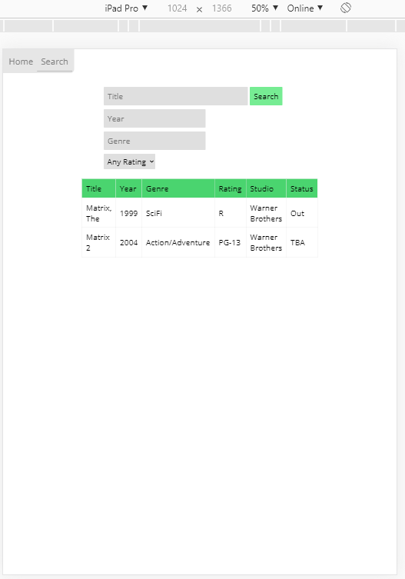

**Tablet** (landscape):

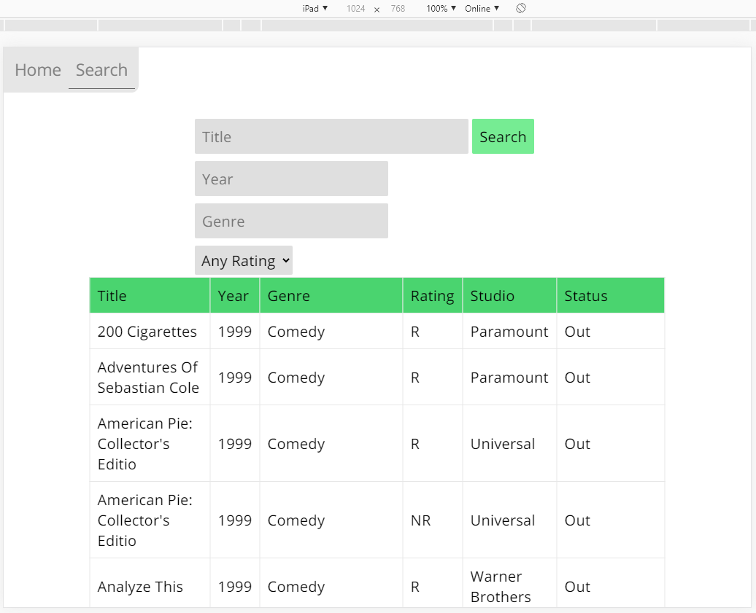

**Mobile** (portrait):

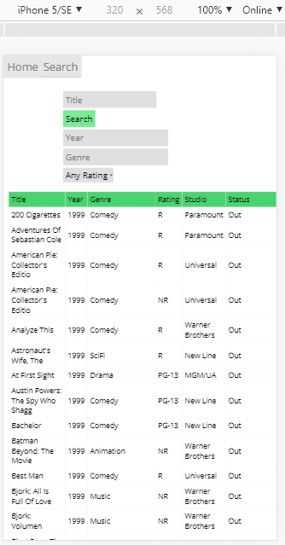

**Mobile** (landscape):

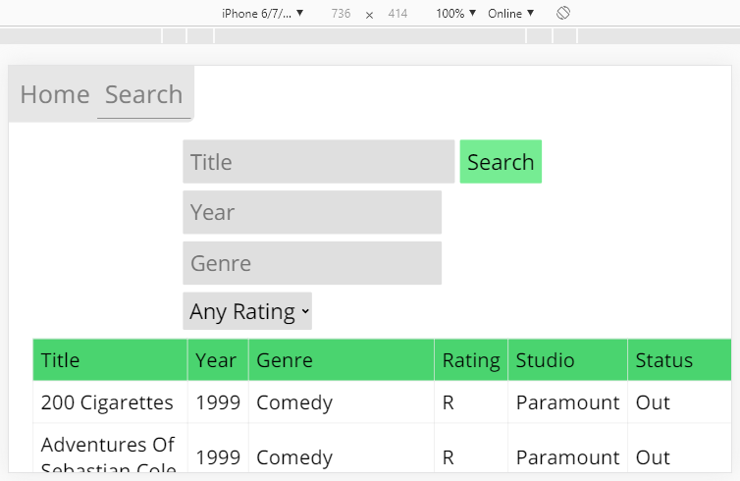

**Desktop**:

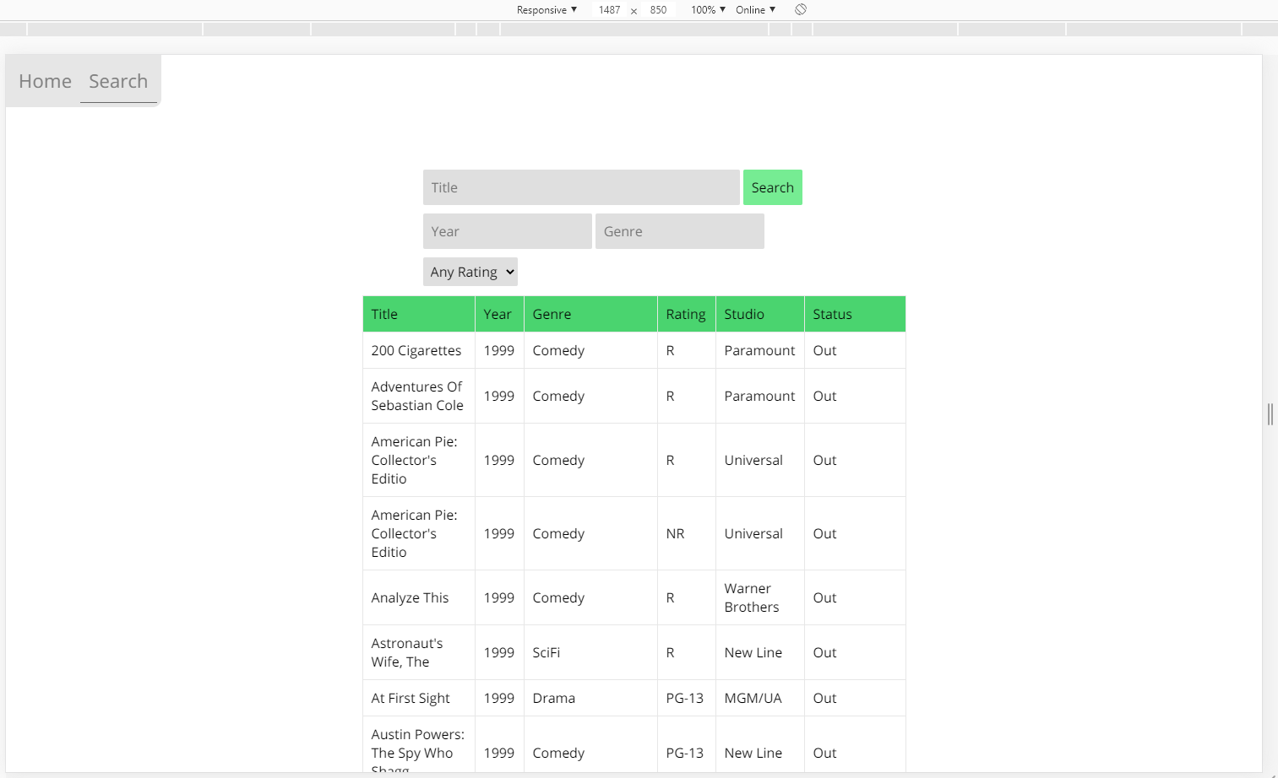

**Home Page** in different sizes

|  |  |
| --- | --- |
|  |  |
|  | |

|  |  |
| --- | --- |
| *Testing the bounds of the Search function…*  **No search filters/Title:** | Only 1 filter applied: **Year = 1** |
| **Genre = a** | **Title = ‘ OR 1 == 1**    The user could possibly find a vulnerability here, so I can insert an IF statement into the code to check that *$result is TRUE* (an error has occurred if mysqli_query() returns false) |
|  | |

# Sprint Two

Scrum Master: Gholamreza